﻿Average Rating

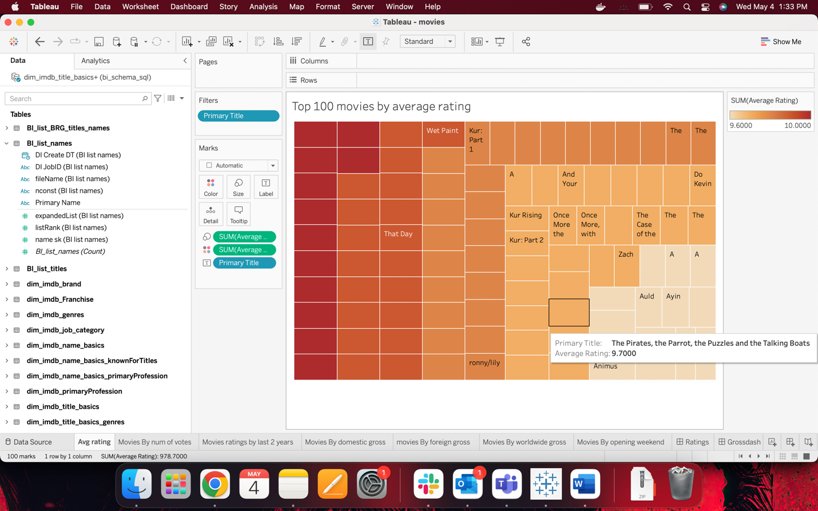

﻿Movies by number of votes

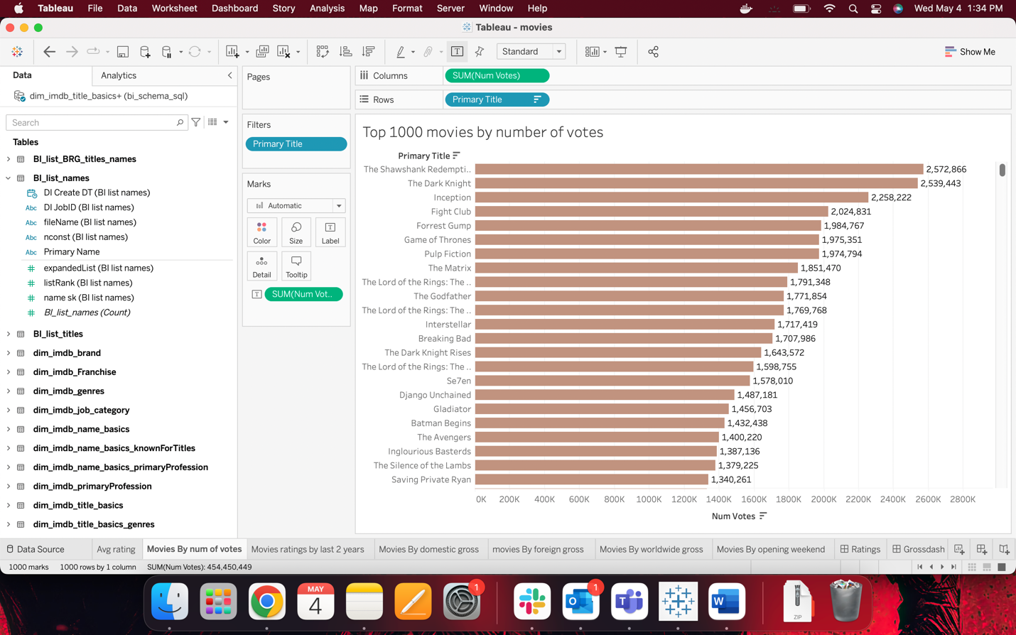

﻿Movies ratings by last 2 years

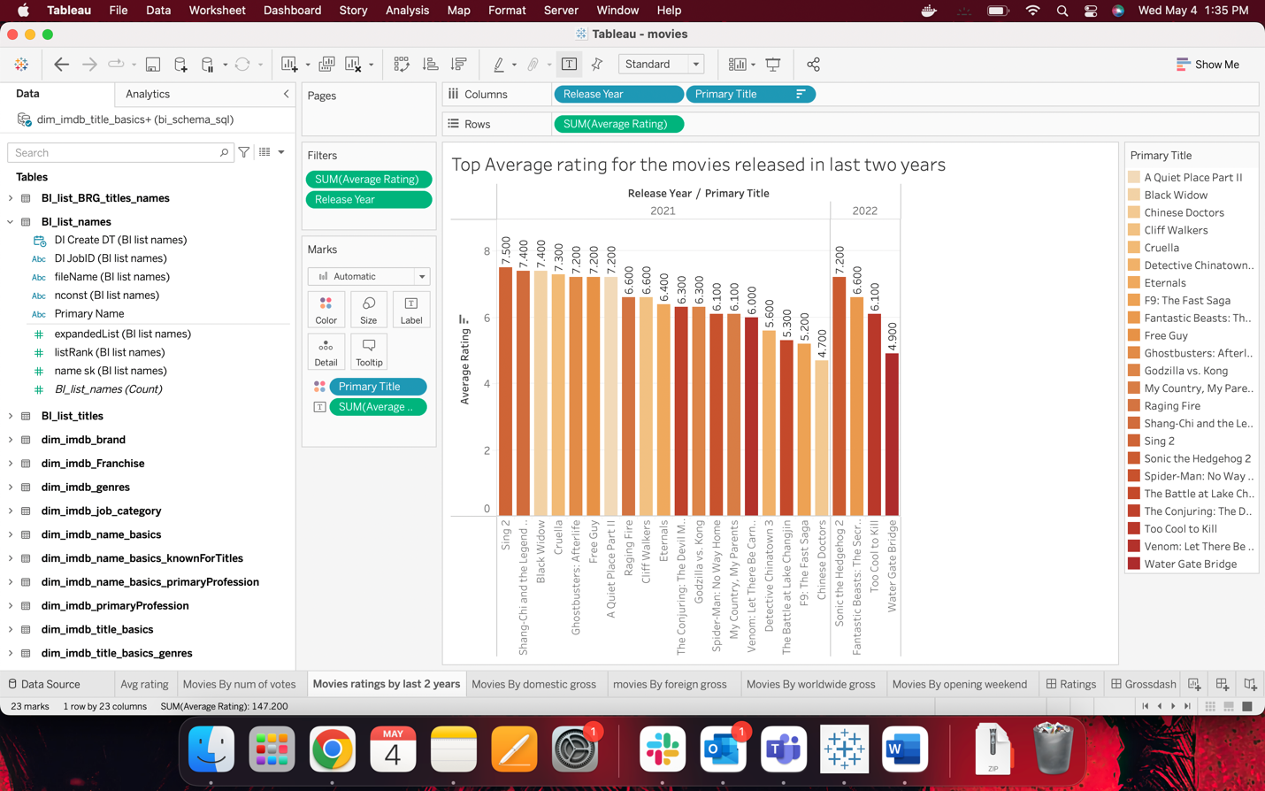

﻿Movies By domestic gross

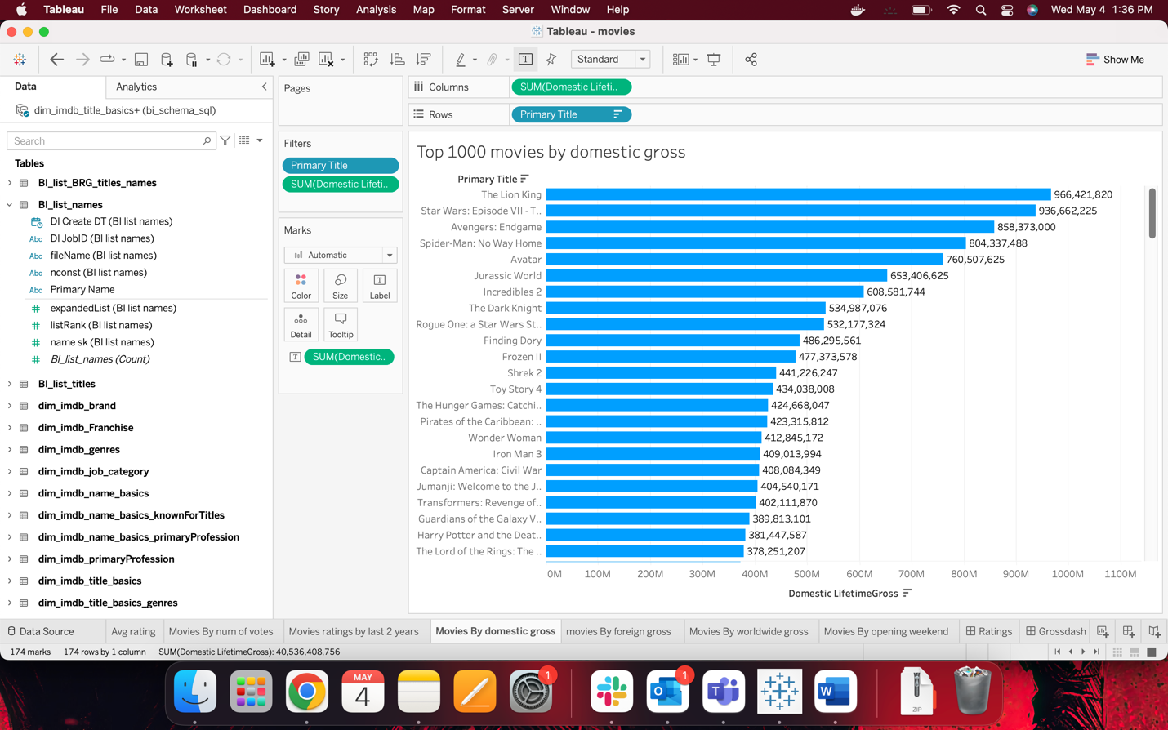

Movies By foreign gross

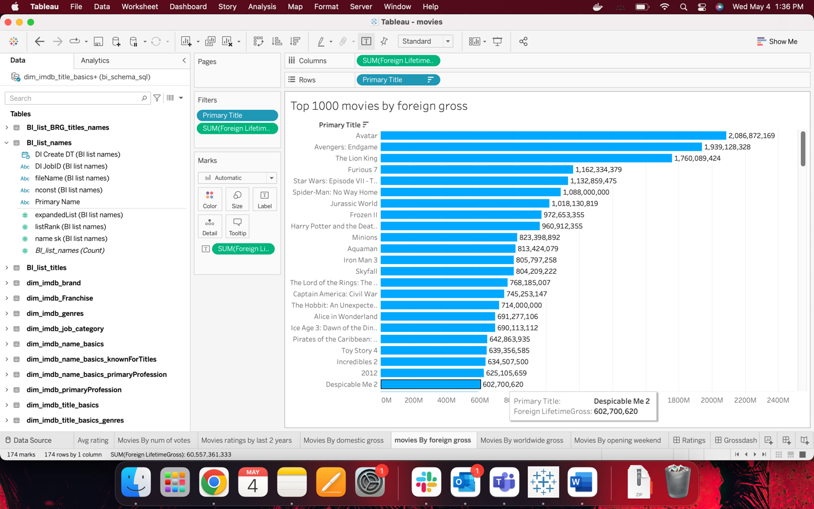

﻿Movies By worldwide gross

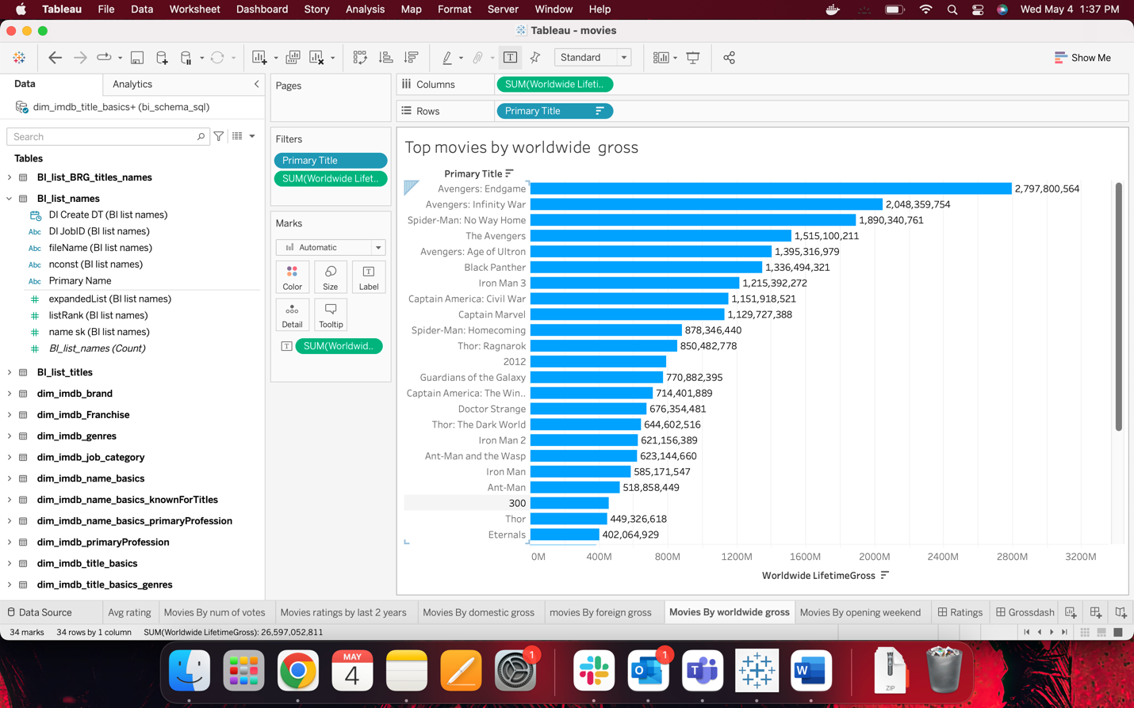

﻿Movies By opening weekend

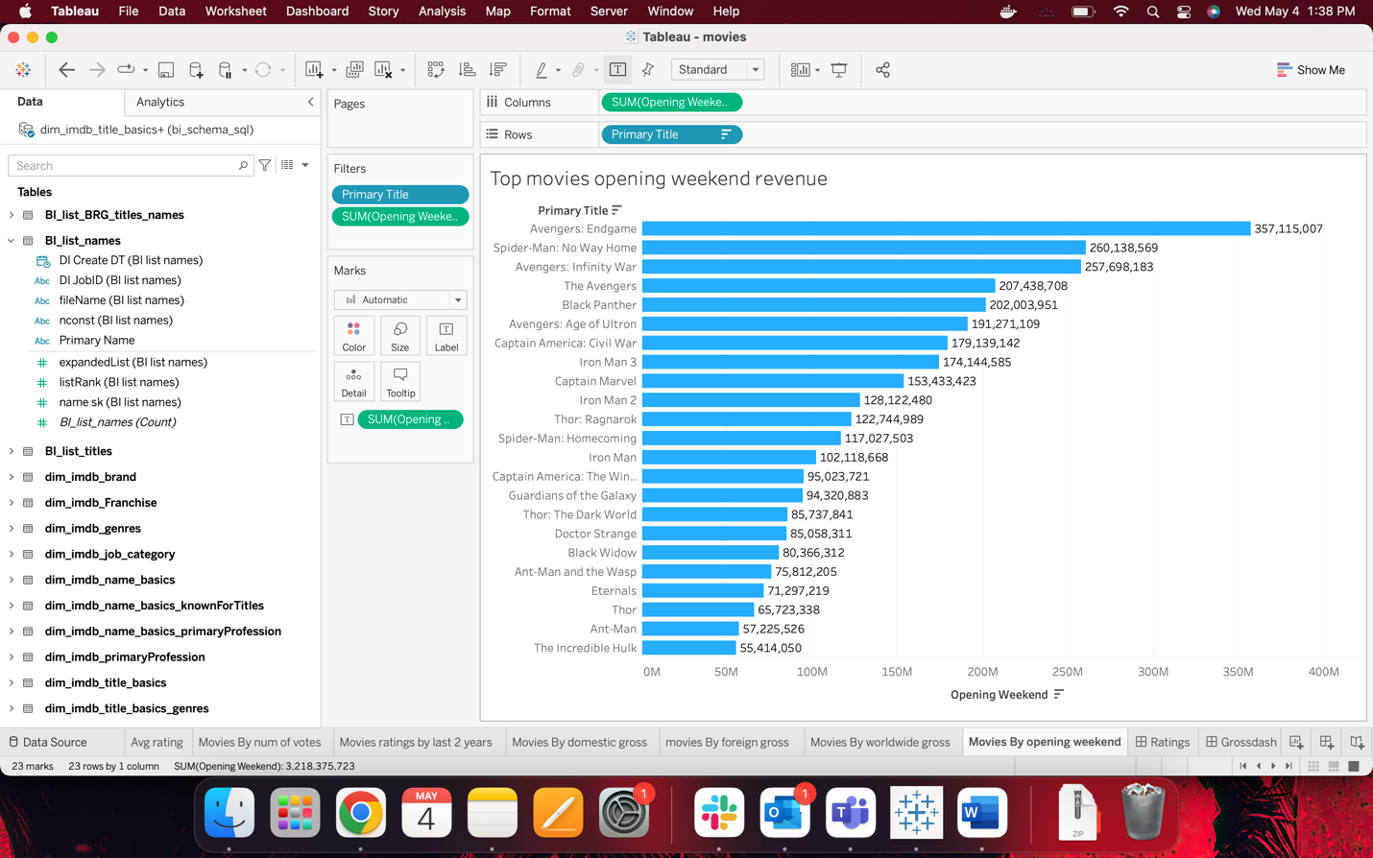

﻿Ratings

1. Top 1000 movies by number of votes
2. Top Average rating for the movies released in last two years
3. Top 100 movies by average rating

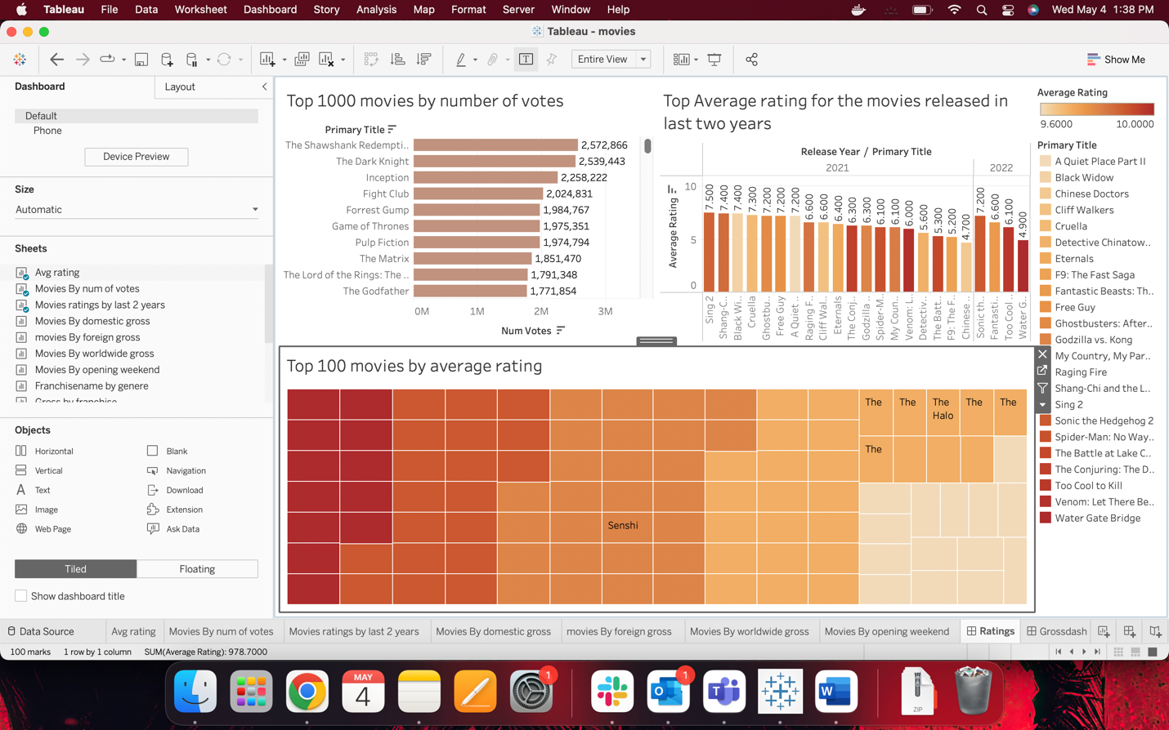

﻿Grossdash

1. Top 1000 movies by domestic gross
2. Top 1000 movies by foreign gross
3. Top movies by worldwide gross
4. Top movies opening weekend revenue

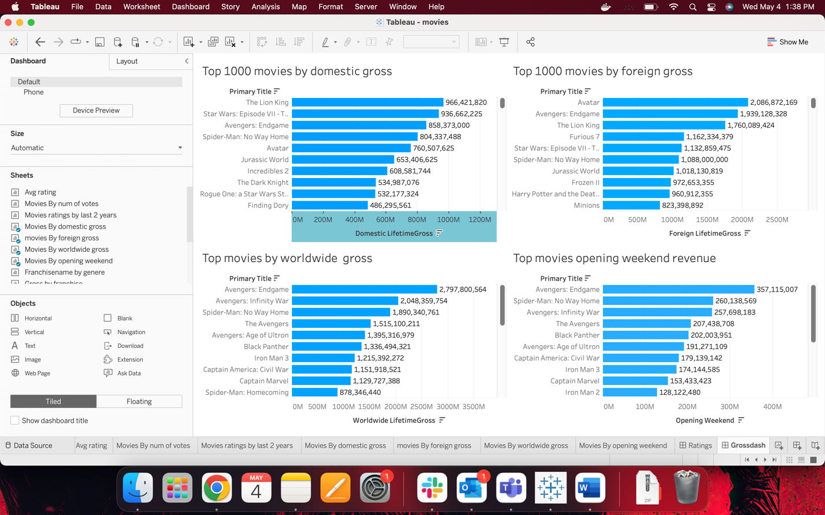

﻿Franchise Name by genre

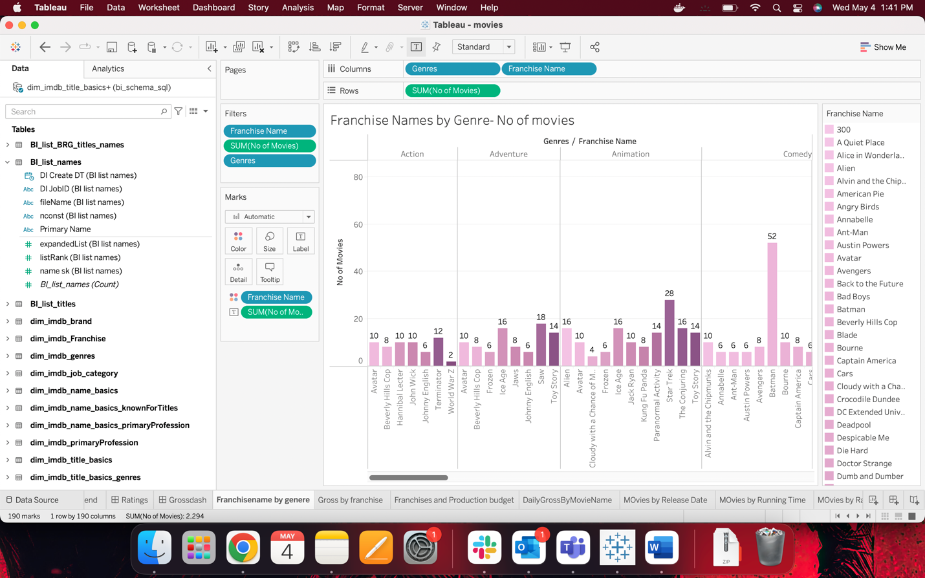

﻿Gross by franchise

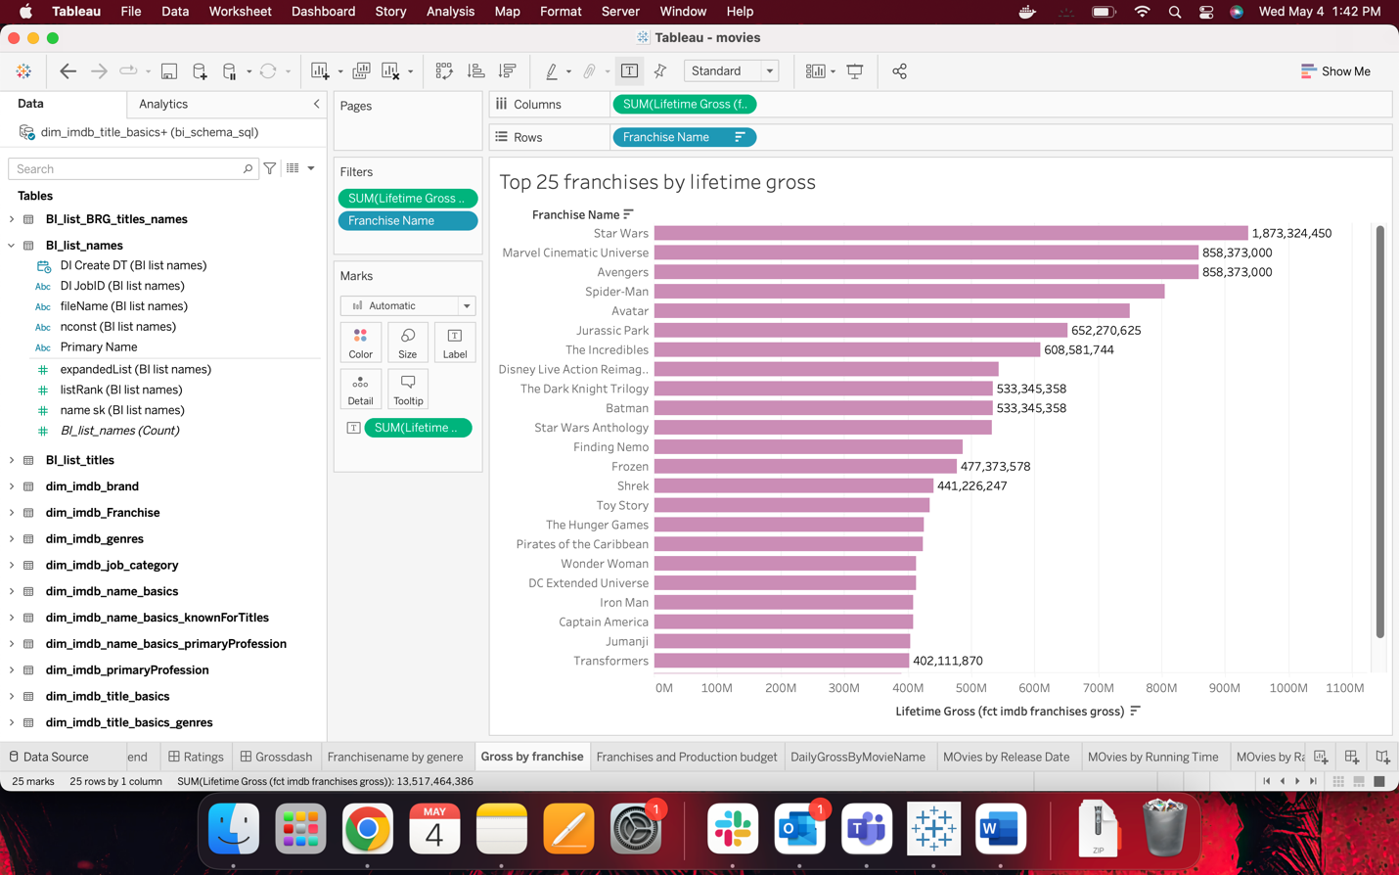

﻿Franchises and Production budget

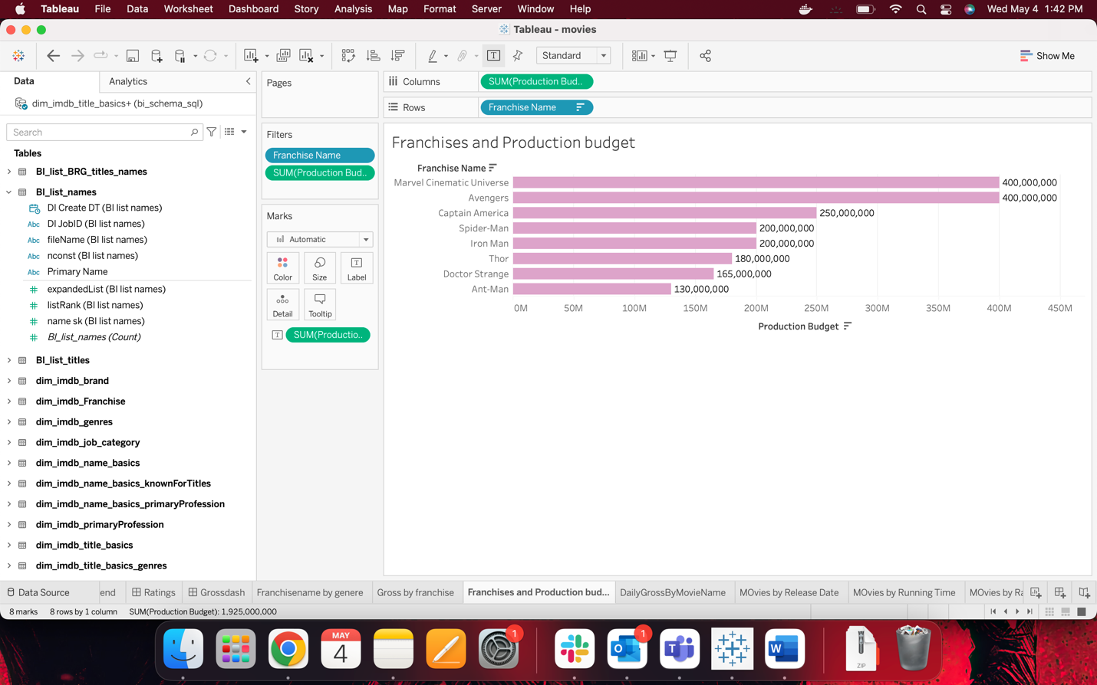

﻿Daily Gross By Movie Name

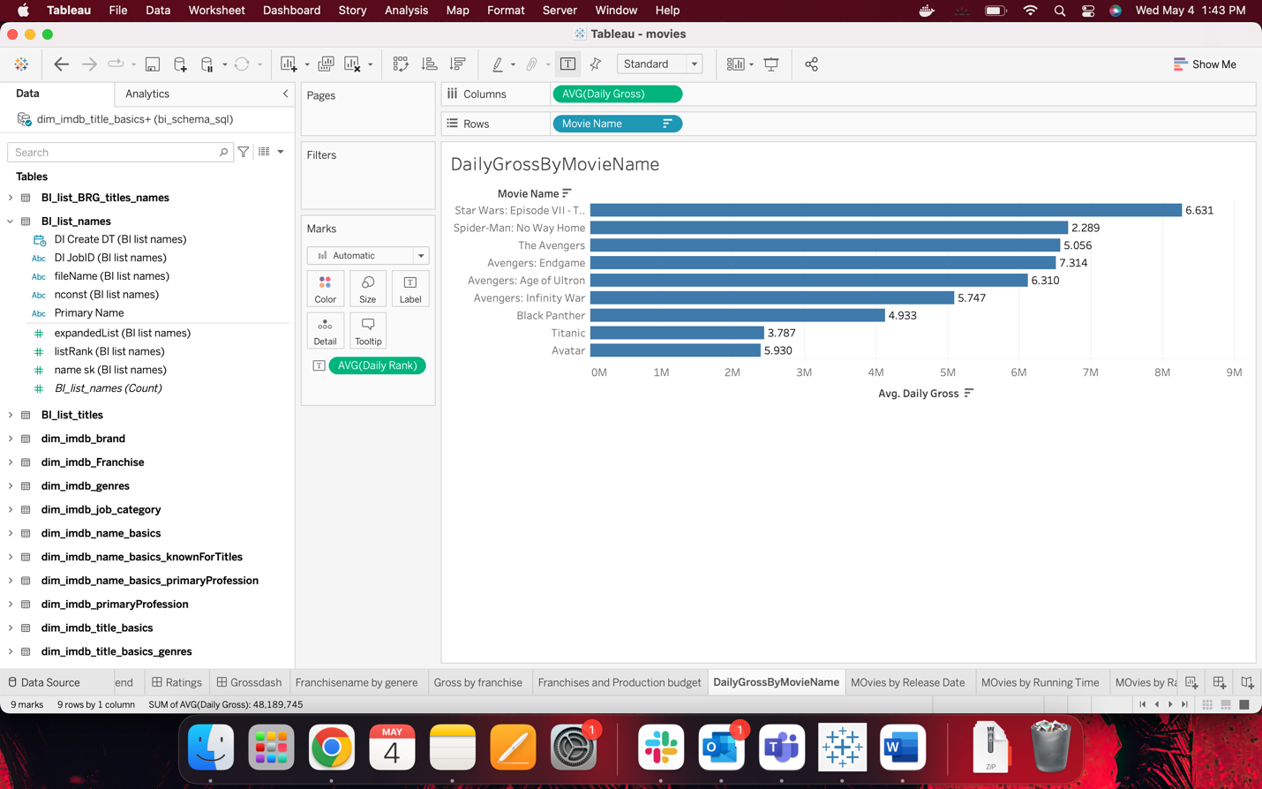

﻿Movies by Release Date

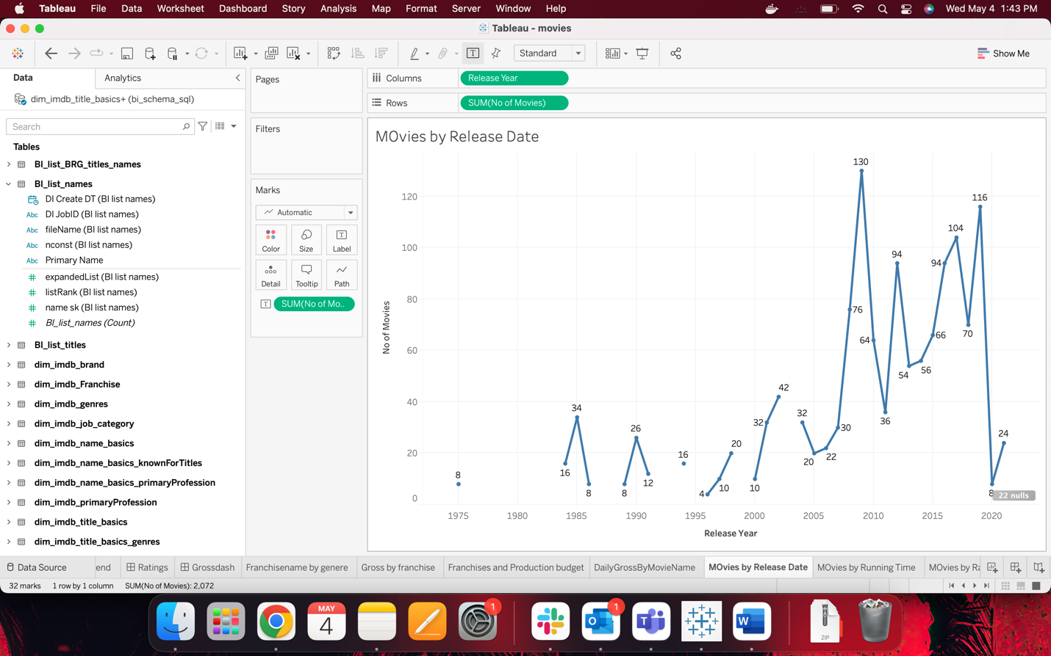

﻿Movies by Running Time

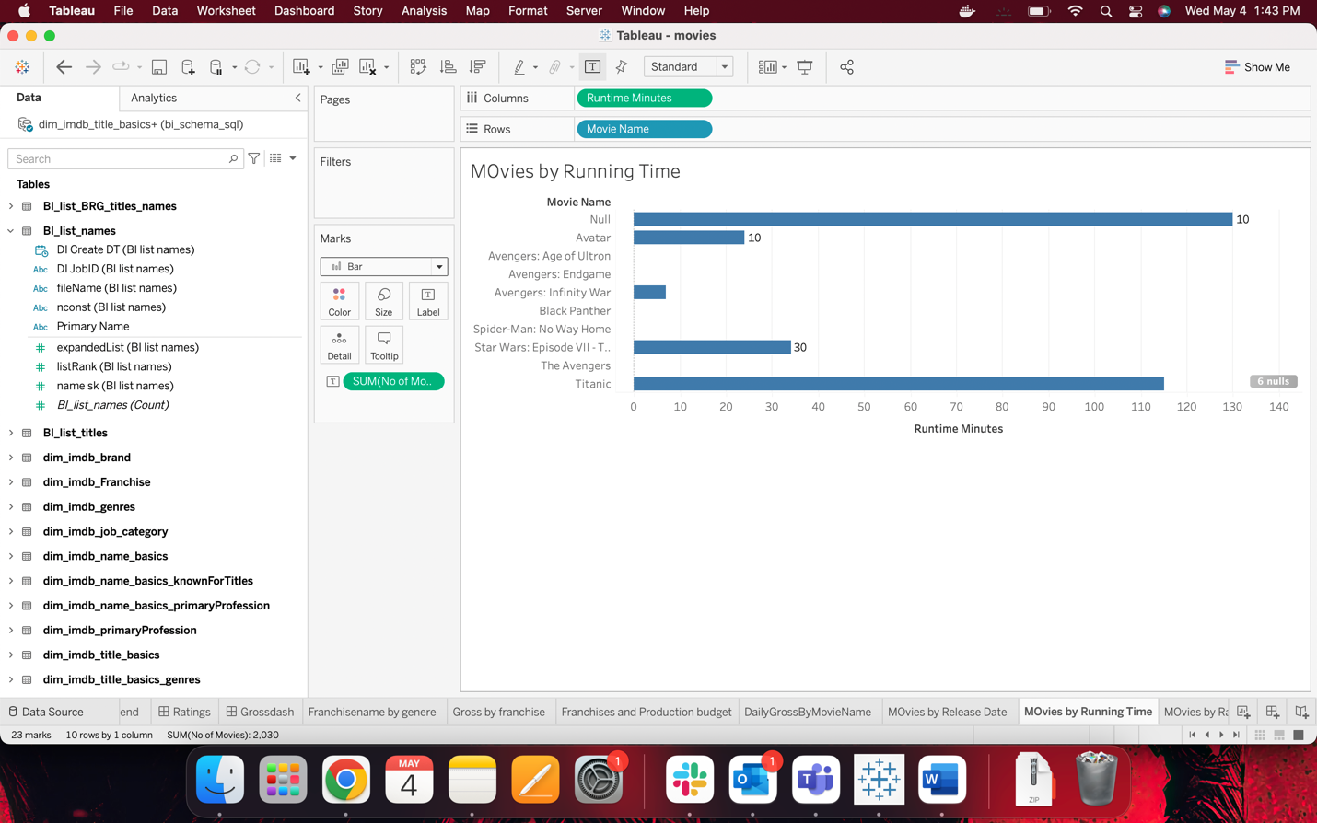

﻿Movies by Ranking

